A000-Bannerstone-Ohio-Adams County

* Bannerstone from Adams County Ohio
* Made from Slate
* Measures 2-7/8"L by 2-1/8
* Originates from the "Woodland to Archaic" period
* Guaranteed to be Authentic
* Ex Patterson Collection

# 

# 

# 

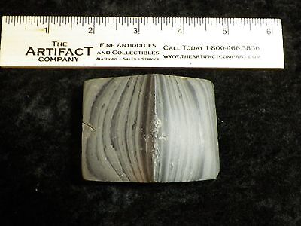

#### [Authentic Ohio Slate Bannerstone Indian Artifact](http://www.ebay.com/itm/191766409979)